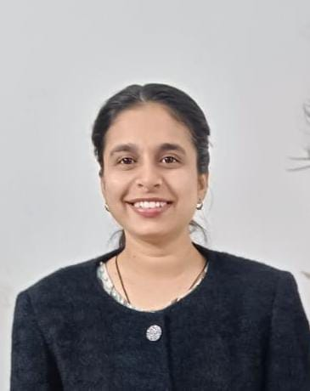

**Dr. Kajol**  
**MD – Psychiatry (**AIIMS Bathinda)

**Contact Information**

📍 Quality Sweet House, Rawla Mandi, Ganganagar, Rajasthan - 335707  
📞 8875343329  
✉️ [ruhs.kajol@gmail.com](mailto:ruhs.kajol@gmail.com)

**Career Objective**

Compassionate and dedicated psychiatrist with an MD in Psychiatry from AIIMS Bathinda, seeking a Senior Resident position in a reputed medical institution. Passionate about mental health, research, and patient-centered care, with specialized experience in neuropsychiatry, psychotherapy, and addiction psychiatry. Committed to holistic treatment approaches and academic excellence.

**Education**

🎓 **M.D. (Psychiatry)** - AIIMS Bathinda, 2025 (Passed)  
🎓 **MBBS** - RUHS Medical College, Jaipur, 2019 (Passed)  
🎓 **XII (R.B.S.E.)** - KVM School, Sikar, 2012 (82%)  
🎓 **X (R.B.S.E.)** - S.V. Children Academy, Rawla, 2010 (91.17%, Merit Holder)

**Internship:** Completed in March 2020  
**UPSC CMSE:** Selected in 2021

**Work Experience**

**🩺 Junior Resident (MD Psychiatry) | AIIMS Bathinda | 2022 - 2025**  
✔ Managed psychiatric disorders in both outpatient and inpatient settings.  
✔ Conducted neuropsychiatric assessments, psychotherapy, and psychopharmacology treatments.  
✔ Specialized in child & adolescent psychiatry, addiction psychiatry, and geriatric psychiatry.

**🩺 Internship Training | RUHS College of Medical Sciences | 2019 - 2020**  
✔ Rotational experience in medicine, surgery, pediatrics, obstetrics & gynecology, and psychiatry.

**Conferences & Workshops**

📌 **Research Methodology Workshop** – Feb 2022  
📌 **ADDICON 2022 Conference** – Dec 2022  
📌 **Annual Midterm CME of IPS-North Zone** – March 2023  
📌 **CME on Understanding Basics of Sleep Disorders & Breathing** – March 2024  
📌 **CME on Basic EEG** – Aug 2024

**Research & Publications**

📖 **Thesis:** "Evaluation of Seasonality and Its Clinical Correlates in Patients Presenting with Depressive Disorder at a Tertiary Care Hospital in North India."  
📖 **Publication:** Letter to Editor (**IJP - Indian Journal of Psychiatry**) – "Delirious Mania or Excited Catatonia: Diagnostic & Management Issues in Postpartum Women."

**Achievements & Awards**

🏆 **3rd Prize in Poster Presentation** – "Revisiting the Forgotten Territory of Abreaction Practice: Description of 4 Cases."

**Skills & Expertise**

✔ Clinical Psychiatry - Diagnosis & treatment of psychiatric disorders  
✔ Neuropsychiatry - EEG interpretation, sleep disorders, neurocognitive assessments  
✔ Psychotherapy - Cognitive Behavioral Therapy (CBT), supportive therapy  
✔ Research & Academics - Strong background in psychiatric research  
✔ Medical Teaching - Experience mentoring junior residents & students

**Extra-Curricular Activities**

🎶 Singing  
🎨 Drawing

**Languages**

🗣 **Hindi:** Fluent (Read, Write, Speak, Listen & Understand)  
🗣 **English:** Fluent (Read, Write, Speak, Listen & Understand)  
🗣 **Punjabi:** Conversational (Speak, Listen & Understand)  
🗣 **Rajasthani:** Basic (Listen & Understand)

**References**

Available upon request.

**Dr. Kajol**  
(MD Psychiatry, AIIMS Bathinda)