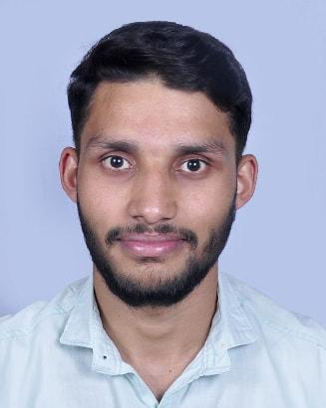  Contact Information  Manjappallikunnel House  Ellakkal P.O, Idukki Dist  Kerala, Pin: - 685565  - +91-9961448527  dinojohn4@gmail.com  Computer Skill Set  Operating systems: - Windows XP, Windows 7, Windows 8 and Windows 10  Basic knowledge about MS Word, MS Excel, PowerPoint 2000 XP, Email and Internet  Languages Known  - English  - Hindi  - Malayalam  - Tamil  - Kannada  Interest and Hobbies  - Reading books  - Listening music  - Watching Debates  - Watching News | DINO JOHN  Career Objective  I want to succeed in a stimulating and challenging environment, building the success of the company while I experience advancement opportunities.  Academic Credentials  - Master of social work  From Holy Cross college (autonomous) affiliated with Bharathidasan University, Tiruchirapalli, Tamil Nadu.  Year of passing: - 2021 Percentage: - 80%  - Bachelor of philosophy  From Jeevalaya Institute of Philosophy, Bangalore  Affiliated to Urbaniana University in Rome  Year of passing: - 2019 Percentage: - 75%  - Bachelor of arts  English Literature  From Ignou University  Year of passing: - 2019 Percentage: - 60%  - Higher secondary(XII)  Board: - Government of Kerala Higher Secondary education.  School: - St. Ephrem’s HSS, Mannanam, Kottayam  Year of passing: - 2015 Percentage: - 74%  - Secondary(X)  Board: - Government of Kerala secondary education  School: - St. Sebastian’s High School Pottankad.  Year of passing: - 2012, Percentage: - 60%  Areas of Interest  - Counseling  - Organizing  - Communicating  - Managements  - Driving  Other Skills  - Have good team building skills.  - Confident and Determined.  - Have pleasing communication skills.  - Having positive attitude and live up to challenges  - Good at sports such as basketball and volleyball  Personal Information  Name - DINO JOHN  Father - JOHN M.U  Date of Birth - 14/9/1996  Gender - Male  Marital Status - Single  Nationality - Indian  Religion - Christian, RCSC  Declaration  I hereby declare that the above furnished details are true to the best of my knowledge and belief.
Place: Idukki DINO JOHN
Date: 14/07/2021

