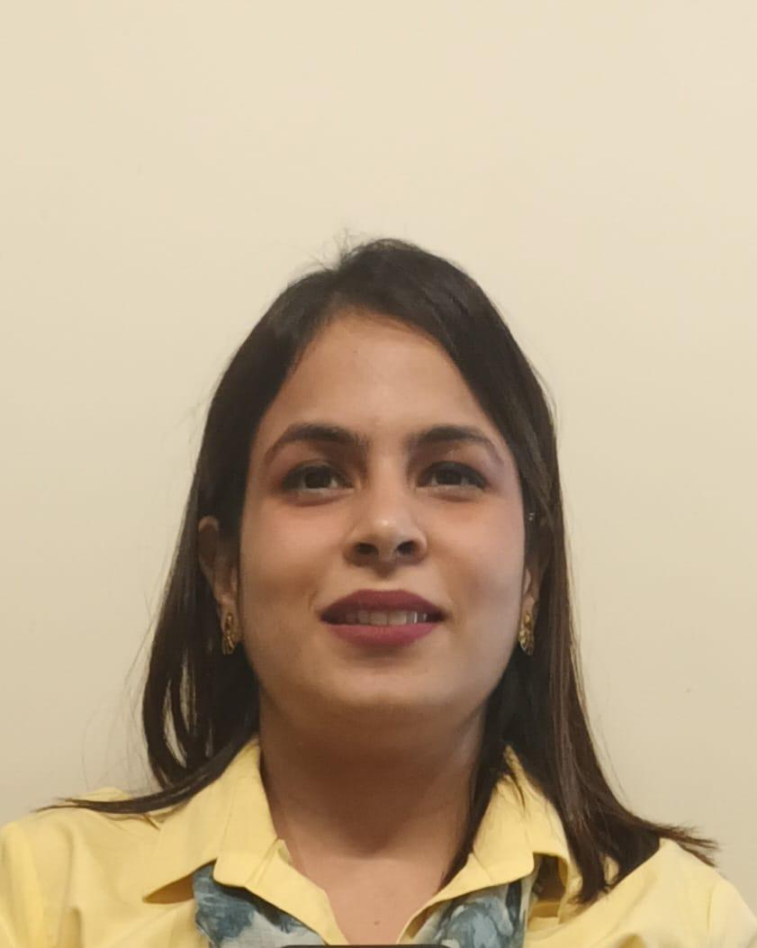 |  | EDUCATION
M.D. (Psychiatry) - AIIMS, New Delhi
2017-2020
- Dissertation in Prevalence and Sociodemographic correlates of gambling disorders in alcohol use disorder patients
- Won 2 Prizes in the Postgraduate development program on psychosexual disorders at AIIMS, Jodhpur
- Attended CME on Child & Adolescent mental health at NIMHANS, Bangalore
- Member IASP

M.B.B.S. - MAMC, New Delhi
2009-2015
Dr.Samridhi Sandooja  Psychiatrist  Summary  A passionate Psychiatrist, dedicated to the profession with a track record of providing first-class patient care. Skilled at listening with empathy, understanding patient needs, and easing anxiety through clear communication. Meets job demands and deadlines through diligent work ethics and dedication to quality. Self-motivated to consistently learn new skills.  CONTACT  PHONE NUMBER:  +91 7011355756  ADDRESS:  Mumbai- 400036  EMAIL ADDRESS:  samridhi1991@gmail.com |  | WORK EXPERIENCE
mPower, the foundation, Mumbai- Psychiatrist & Clinical head
10/2023- present
- Performed psychiatry consultations(both online & offline) and physical examinations, assessing, and planning individual treatment requirements within a timeframe.
- Regular L&D sessions discussing various kinds of therapy
- Regular clinical discussions to formulate holistic treatment for clients with inputs from the multidisciplinary team & referring for required therapies
- Quality assuarnace by ensuring regular one on one supervisory sessions with the therapists.
- Managed a multidisciplinary team consisting of Psychologists, Occupational therapists, Speech therapists, Special educators.
- Pursuing course in Child & Adolescent Psychiatry by IACAM.

BYL Nair and Ch.Hospital, Mumbai- Senior Medical Officer
05/2023- 10/2023
- ICMR Project on psychosocial impact of COVID-19 pandemic on Children with psychiatric disorders; and their families

Institute of Human Behavior and Allied Sciences, Delhi- Senior Resident
04/2022- 05/2023
- Performed patient consultations and physical examinations, assessing, and planning individual treatment requirements within a timeframe.
- Supervised and mentored MD trainee doctors and, provided constructive feedback.
- Working with a multidisciplinary team of Psychologists, Social workers, Occupational therapists, and psychiatry nursing staff to deliver quality care for common and severe mental illness as well as SUDs
- Authored a chapter on Psychiatry emergencies for a book for undergraduates
- Presented a symposium on Alcohol use disorders and management in the COVID pandemic in World Congress of Asian Psychiatry

NABH Accredited Psychiatry Setup - Consultant Psychiatrist
08/2021-03/2022
- Assessment and personalized management of mental illness in both OPD & IPD settings.
- Supervised and mentored trainee psychologists in common as well as severe mental illness.
- Management of psychiatric illness with a multidisciplinary team consisting of Clinical & Counselling Psychologists, Psychiatric nurses, medical officers and dieticians

Maharaja Agrasen Medical College, Hisar - Senior Resident
07/2020-07/2021
- Performed patient consultations- assessment followed by planning of "tailor-made" treatment regime.
- Supervised and mentored trainee doctors, providing them with insights into the field of Psychiatry.
- Liased with medical and non-medical staff, ensuring quality treatment both in OPD and IPD settings.
- Liased with other departments for managing the behavioral aspects of medical illnesses during COVID times.

