**Resume**

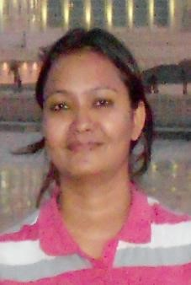

**MADHURIMA SINGH**

Address: Flat no-1004, Orchid C, Omaxe Residency-1, Gomti Nagar Ext, Lucknow

Contact No.: 9005526086

Email: madhuhoney19@gmail.com

**Objective:**

More than 15 years of work experience with specialization in governance, communication, women and child rights, education. Psychological assessment counselling sessions. Having a strong leadership quality along with understanding the value of team work and a strong interpersonal communications and project management skills. Have experience in working with Government as well as social sector.

**Academic Details:**

* Post-graduation diploma in Counselling and Guidance Course from NCERT, DELHI.
* Post-Graduation & Professional Course with applied psychology, Area of specialization in clinical psychology from V.B.S. Purvanchal University, Jaunpur in 07/2003 – 05/2005.
* Graduation with science from Meerut University in 2002

**Work Experience:**

* Working as a Practioner Counsellor.
* Worked as a Consultant Counsellor for covid effected children of slum and communities, Lucknow.
* Working as a State Resource Person, Panchayati Raj Department.
* Worked as a School Counsellor in Kendriya Vidyalaya, Lucknow.
* Worked as consultant and trainer for multiple Project in different organization 8/2012-2/2014
* Program Associate (Lucknow) 9/2011-8/2012, Aangan Trust, Mumbai
* Co-Worker Education (Grown up Girls) 06/2008 - 11/2008, SOS Children Village, Choubeypur Varanasi (UP)
* Project Coordinator (child line) Varanasi, 11/2005 – 12/2007

**Program Contribution:**

* Worked with target Group (HIV+ Patient) as a Counselor
* Did Intervention Program on Railways Station Varanasi Cantt.
* Outreach Program on HIV/AIDS in Police Stations (All major Police Station of Varanasi & nearby) to train Police departments (Senior as well as Junior Staff).
* Consultant counsellor of effected covid children in different slums and communities, Lucknow.