 |  | personal information
Name: Sreyashi Roy

Date of birth: September 8, 1993

Father’s name: Santanu Roy

Mother’s name: Soma Roy

Marital status: Unmarried

Nationality: Indian

Permanent address: 32A/31, Suren Sarkar Road.
Kolkata-700010

Contact address: B-303, Aditya Sunshine, Kondapur. Hyderabad- 500084

Languages Known: English, Hindi and Bengali

Hobbies: Reading, Creative Writing, Singing, Sketching and Travelling

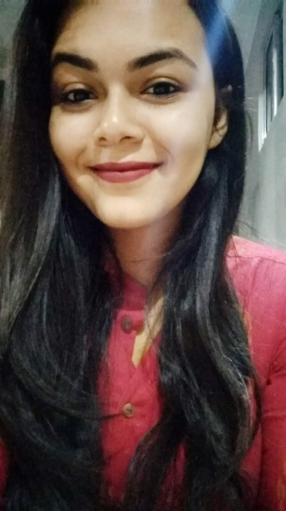  SREYASHI ROY  COUNSELLING PSYCHOLOGIST, EDUCATOR  OBJECTIVE  To obtain a challenging and rewarding position as a psychologist where I can utilize my extensive training to work collaboratively with individuals, families, and communities to promote psychological well-being and improve overall quality of life,  CONTACT  PHONE:  7688070558  EMAIL:  sreyashiroy.8@gmail.com  SKILLS  Communication Skills: Fluency in English, Hindi and Bengali.  Fast & Proficient IT: MS Office, SPSS, Database Management System, Internet.  Personal Skills: Creative, responsible, committed, with good communication and problem-solving skills.  PUBLICATION  Fear of Negative Evaluation, Relationship Structure with Spouses, Shame and Guilt as Predictors of Resilience among Mothers of Exceptional Children from Lucknow and Kolkata.  International Journal of Indian Psychology · May 6, 2023  International Journal of Indian Psychology, 11(2), 683-702. |  | ACADEMIC CREDENTIALS
- 2022- Pursuing Clinical Hypnotherapy from EKAA Foundation. Currently in Level-2 with expertise in age regression therapy.

- 2021-23: MA in Counselling Psychology from Amity University, Lucknow with cgpa of 9.56.

- 2021: Completed B.Ed. from West Bengal University of Teachers' Training, Education Planning and Administration with 9.2 cgpa.

- 2017: Teacher Training Certificate from Modern Academy of Continuing Education, Kolkata.

- 2015: B.com (Hons) from Heramba Chandra College, Kolkata with 52.67%.

- 2012: AISSCE from Mahadevi Birla Girls’ Higher Secondary School, Kolkata with 74.75%.

- 2010: AISSE from Mahadevi Birla Girls’ Higher Secondary School, Kolkata with 9.60 CGPA.

 |  | work experience
- Currently working at Ananya Child Development and Early Intervention Clinic as Child Psychologist and Behavioural Therapist.

- Completed one month of internship at National Institute for Empowerment of People with Intellectual Disability, Secunderabad from July-August’ 2022.

- Worked at Indus Valley World School, Kolkata from 2019-21 as Assistant Teacher in the Primary Department.

- Worked as a creative writing instructor for Word Munchers, Kolkata from 2020-21.

- Worked at The Heritage School, Kolkata from 2017-19 as Assistant teacher in the Primary Department.

