**CURRICULUM VITAE** 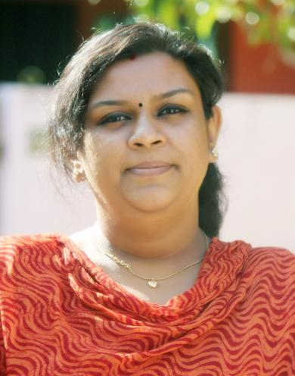

**Dr. AMRUTHA VIJAYAN Phone: 8113934279**

**Vaishnavam**

**Punnakal**

**Elamakkara**

**Ernakulam Email : dramruthavjnp13@gmail.com**

**OBJECTIVE:**

To be part of a reputed institution, and to contribute my best to the growth of the institution and the society, by using the best of my abilities as a trainer and to upgrade my experience and expertise.

**WORK EXPERIENCE:**

**December 2010 – 2013 January:**

Patient counselor and Public Relation Officer, Department of Bariatric Surgery, Obesity solution NIMS Hospital Trivandrum

.

**2013 Feb –2015 August-** worked as Consultant Psychologist , student Trainer and mentor at Lekshmi Hospital, Aroor, Alapuzha.

**Worked** as psychology teacher and student counselor Paramekkavu Vidyamandir CBSE School, Thrissur

**Worked** as enhancement and IB psychology teacher and student counselor at The Choice School,(**2019** **December-2023 January)**

Ernakulam

**2015 September – 2019 November:** working as counseling psychologist at Punarnava Group of Hospital, Ernakulam.; Thaqdees hospital Aluva and Sanjeevanam hospital kkakkanad

**Presently** working as Consultant Psychologist and behavioral therapist at Naval base hospital Sanjivani, Kochi

**EDUCATION QUALIFICATION**

|  |  |  |  |  |
| --- | --- | --- | --- | --- |
| Sino | **COURSE** | **UNIVERSITY** | **YEAR** | **MARKS** |
| 1. | Phd( Psychology) | UNESCO | 2016 |  |
| 2. | MA PSYCHOLOGY | BUNDALKAND UNIVERSITY | 2009 | 69% |
| 3. | Bcom PUBLIC RELATIONS | ORISSA UNIVESITY | 2006 | 64% |
| 4. | DIPLOMA In PSYCHOLOGICAL COUNSELING | CALICUT UNIVERSITY | 2014 | **66**% |
| 5. | Senior Naturopath | Govt of India | 2014 |  |
| 6. | HIGHER SECONDARY | NATIONAL INSTITUTE OF OPEN SCHOOLING | 2002 | 70% |
| 7. | |  | | --- | | SECONDARY | | CBSE | 2000 | 79% |

**TRAININGS ATTENDED:**

* International Stress management conference at Hyderabad on November 2015.
* Two months intensive course on Child Psychology from WWF. ( Institute of Counseling and behavioral Sciences)
* Special Training on ENNEAGRAM for two weeks from WWF.
* Special Training on Stress Management and Meditation from Vedic Vision.
* Intensive Course on CBT and Management of ADHD Children conducted by NIMHANS Bangalore
* Master degree in hypnotheray
* Master ship in REIKI

**PROJECT:**

* Conducted a Seminar on Feb 22 2014 in Personality Development for children below the age of 12.
* Conducted a Seminar and Training Program as a Summer Class of 5 days named “Venal Veedu” for children above 12 – 24 years on April 2014

**PAPER PRESENTATION :**

* Thesis on treatments in psychological disorders clubing western psychology and eastern Ayurveda (PSYCHO VEDA) 2016
* A paper on “Emotional and family stress of creative professionals” was presented at International Stress management conference at Hyderabad on November 2015.

**RESPONSIBILITES HELD:**

* Director of summer camp held for kids at Sathyan Memorial Hall Trivandrum on 2014 April 21-25.
* Chief Organizing member of Psychological Trainings held by WWF at Trivandrum.
* Class Representative at college and Higher Secondary levels.
* Guides Captain at school levels.
* House Captain at school levels.

**EXTRA CURRICULAR ACTIVITES:**

* Active Organizing member in various trainings, functions and seminars held for Public.
* Secured prices for various events in both sports and Arts in School levels.
* 3 years consecutive inter school Badminton Championship.
* Awarded best Elocutionist of the School in 1997.
* Awarded the Talented Student of School in 2000.

**PERSONAL DETAILS:**

* Father’s Name : P. Vijayakumar
* Date of Birth : 13/03/1986
* Languages : English, Malayalam, Hindi and Tamil