#### CURRICULUM VITAE

### Anil Kumar

Flat No – C, First Floor, Royal Tower-C,

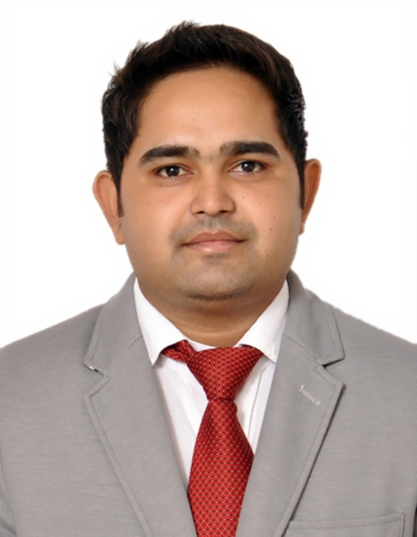

Sidharth Vihar Residency, Sidharth Vihar

Ghaziabad–201009, India

Mobile No: +91- 8810494568, 9582101006

**Email:**[anilk2427@gmail.com](mailto:anilk2427@gmail.com)

**PROFESSIONAL EXPERIENCE –5+ years**

**CURRENT CTC – 3.84 Lacs per annum**

**SALARY EXPECTATIONS – As per industry**

**SUMMARY**

Dedicated and focused Project Officerwith solid record of project delivery on time, under budget and at optimum quality as part of collaborative, communicative teamswho excels and prioritizing, completing multiple tasks simultaneously, and following through to achieve project goals. Answer a high volume of incoming calls while handling in-person inquiries from the Doctors, Head of Institution and colleagues. Flexible and hardworking with strong drive to succeed.

**Indian Council of Medical Research (ICMR), New Delhi, Delhi**

**(PROJECT OFFICER, Feb 2021 to till date)**

Job Description:

* Currently handling more than 100 research projects in across India.
* Develop and manage the budget for each project working with the Program Manager, and meeting planner.
* Manage, supervise and control multiple projects through the project life cycle.
* Provide technical back-stopping support to the Program Officer.
* Manage other projects, which are going on in other health institutions and issue budgets or other correspondence.
* Perform any other duties as required.
* Managed day-to-day operational support activities for the departments.
* Travel, Transport & Accommodation arrangements for our internal/external clients
* Handling and participating in Admin internal/External audits and implementing action plans to avoid any observations pointed.
* R&M of facility civil, fabrication, sanitary, plumbing & carpentry work.
* Coordination with vendors for Job work/material supply/AMC and payment follow-ups.

**Authority for Advance Rulings (Income Tax) NCR Bench, Deptt. of Revenue, Ministry of Finance, Govt. of India, New Delhi, Delhi**

**[D.E.O. (Worked as Admin Assistant), Dec. 2016 to Dec. 2019]**

* Provide comprehensive administrative and personal support to the Commissioner of Income Tax, with the scope of responsibility that includes dictation, correspondence, office management, vendor relations, appointment scheduling, travel coordination.
* Coordinating with various Hotel’s for corporate booking & negotiation for rooms & Banquette tariff.
* Working as PD on Public Financial Management System (PFMS) for a processing payment of vendors and various bills like; Domestic Travel Expense Bills, Medical Bills, Tuition Fee Reimbursement Bills & MTNL telephone bills etc.
* Coordinate with vendor for better services and employee’s grievances.
* Assisted with payroll systems.
* Making a tender document for the purchase of machinery & equipment for concern department.
* Type correspondence, reports, text and other written material from rough drafts.
* Update Data in Database.

**BEES HIVE AGRO PRODUCTS, New Delhi, Delhi**

**(Admin. Assistant, Aug 2015 to Oct 16)**

* Obtain customers’ names, addresses, and billing information, product numbers, and specifications of items to be purchased, and enter this information on order forms.
* Prepare invoices, shipping documents, and contracts.
* Receive and respond to customer complaints.
* Recommend type of packing or labelling needed on order.
* Operate office equipment such as fax machines, copiers, and phone systems, and use computers for spreadsheet, word processing, database management, and other applications.
* Answer telephones and give information to callers, take messages, or transfer calls to appropriate individuals.
* Schedule and confirm appointments for clients, customers, or supervisors.

**Facility Management**

* Managed day-to-day operational support activities for the departments.
* Travel, Transport & Accommodation arrangements for our internal/external clients
* Handling and participated in Admin internal/External audits and implementing action plan to avoid any observations pointed.
* R&M of facility civil, fabrication, sanitary, plumbing & carpentry work.
* Co-ordination with vendors for Job work/material supply/AMC and payment follow-ups.
* Managing the stationery purchasing, issuance and stock.
* Maintaining proper checklist related to housekeeping activities to ensure upkeep of the facility.
* Giving training & induction to housekeeping supervisors & houseboys.
* Maintaining hygienic environment & quality standard.
* Coordinating with vendor for better services & employee’s grievances.
* Monitoring security services for safety & smooth operation of the facility

**ALL INDIA INSTITUTE OF MEDICAL SCIENCES (AIIMS), New Delhi, Delhi**

**(Data Entry Operator, Nov 13 toJul 2015)**

* Organizing a conference & meetings also taking grant for conference from various funding agencies (DBT, DST, ICMR and UGC).
* Taking travel grant from various funding agencies (DBT, DST, ICMR and UGC) for travelling from outside the country for attending conference.
* Making a tender document for the purchase of machinery & equipment for concern department.
* Operate office machines, such as photocopiers and scanners, facsimile machines, voice mail systems, and personal computers.
* Answer telephones, direct calls, and take messages.
* Maintain and update filing, inventory, mailing, and database systems, either manually or using a computer.
* Open, sort and route incoming mail, answer correspondence, and prepare outgoing mail.
* Complete work schedules, manage calendars, and arrange appointments.
* Review files, records, and other documents to obtain information to respond to requests.
* Make travel arrangements for office personnel.
* Set up, adjust, and operate audio visual equipment such as cameras, film and slide projectors, and recording equipment, for meetings, events, classes, seminars and video conferences.
* Managing Events & Client visits arrangements.
* Coordinating with various hotel’s for corporate booking & negotiation for rooms & Banquette tariff.
* Coordination with team to book flights, ground transportation and hotel accommodations, and provides travelers with directions and destination information.
* Coordination with various vendors for organizing the company events, off sites, official meetings.
* Coordination with legal offices to fulfill all statutory requirements related to events management.

**MINISTRY OF FINANCE, DEPTT. OF DISINVESTMENT, New Delhi, Delhi**

**(Data Entry Operator cum Personal Assistant, Apr 2012-May 2013).**

* Operate office machines, such as photocopiers and scanners, facsimile machines, voice mail systems, and personal computers.
* Prepare meeting agendas, attend meetings, and record and transcribe minutes.
* Make travel arrangements for office personnel.
* Complete work schedules, manage calendars, and arrange appointments.

**CENTRAL BUREAU OF INVESTIGATION (CBI), New Delhi, Delhi**

**(Lower Division Clerk (LDC), May 2010-Jun 2011).**

* All administrative work like proper maintaining of file and official records, drafting the letters, note-sheet etc.
* Making the presentation of official meeting and also associated with preparation and making of tender document for the purchase of machinery & equipment for concern department and secretarial work.

**MEDSAVE HEALTHCARE TPA LTD., New Delhi, Delhi**

**(Data Entry Operator, Jan. 2009-Feb. 2010).**

* Entering, updating, and verifying patient's information and lab reports data.
* Ensuring accuracy of data entered into the computer program.
* Tracking supporting documents for verification of data.
* Typed test reports and other details of patients and saved them in digital format.
* Sorted, prioritized, and entered data from papers into the computer program.
* Checked and got verified the authenticity of data from subject matter experts.

**EDUCATIONAL QUALIFICATIONS:**

* **Pursuing of Master of Arts in English** from Indira Gandhi National Open University.
* **Bachelor of Arts** from Delhi University.
* **12th Passed** from CBSE Board.
* **10th Passed** from CBSE Board.

**PROFESSIONAL QUALIFICATIONS:**

* **Pursuing of MBA (International Business)** from Annamalai University, Tamil Nadu.
* **Computer Certificate**including MS Office (MS Word, MS Excel, MS PowerPoint), Internet.
* **Diploma** in Stenography from career Commercial Institute Kidwai Nagar, Delhi.
* Typing speed 45 wpm.
* Pursuing Certificate Course in FRENCH Language from Indira Gandhi National Open University.

**PERSONAL PROFILE:**

**Father’s Name** : Sh. Suresh Pal

**Date of Birth** : 15th April, 1989

**Languages Proficiency** : English and Hindi

**Nationality** : Indian

**Hobbies** : Playing with kids

**Social Network URLs** : <https://www.linkedin.com/in/anil-kumar-150163167/>

I declare that all the above mentioned information and facts are true to the best of my knowledge and belief.

**(ANIL KUMAR)**