**CURRICULUM-VITAE**

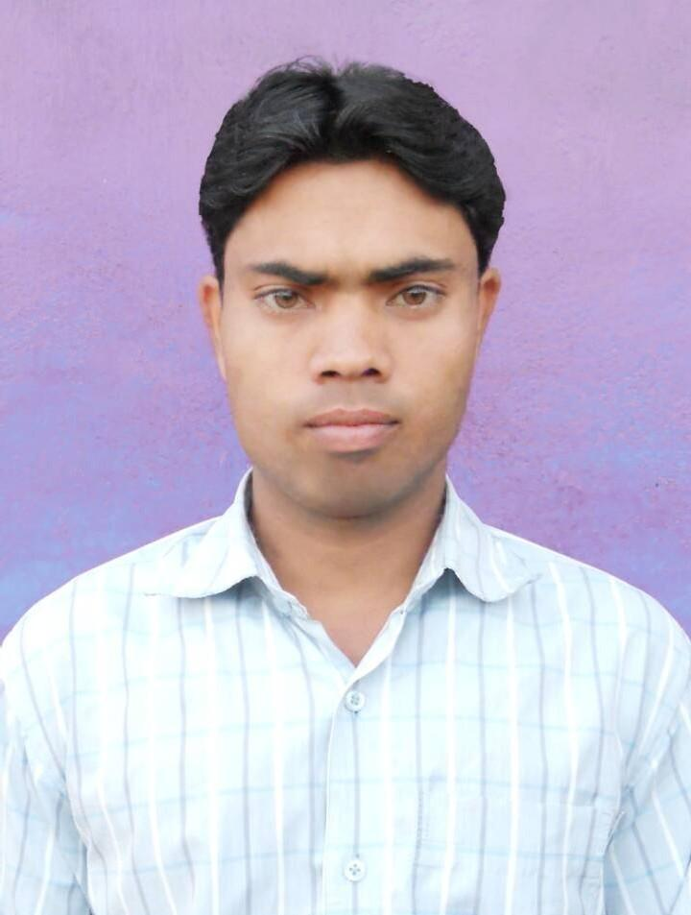

|  |  |
| --- | --- |
| **AFTAB ANSARI**  (RCI Registered Clinical Psychologist)  Mobile: +91-7549029610  Email ID: [Aftab031290@gmail.com](mailto:Aftab031290@gmail.com) |  |

**CAREER OBJECTIVES:**

A position with an organization providing opportunity to contribute by utilizing experience, training and capabilities along with the personal success in life.

**ACADEMICS QUALIFICATION:**

| Degree | Board/University | Collage/Institution | Stream | Passing year | Percentage |
| --- | --- | --- | --- | --- | --- |
| Metric | J.A.C | Govt. High School, boreya | Hindi, Eng, Math, Science and Social Science | 2005 | 61.6 |
| Intermediate | J.A.C | S.S Memorial Collage Ranch | Eng, Math, Bio, Phy and Che | 2008 | 51.4 |
| Graduation | Ranchi University Ranchi | S.S Memorial Collage Ranch | psychology (Hons) | 2011 | 55.6 |
| Post-Graduation | Himalayan University | Himalayan University Arunachal Pradesh | Psychology | 2016 | 65.2 |
| M.Phil | Ranchi University Ranchi | Ranchi institute of neuropsychiatry & allied sciences (RINPAS) | Clinical psychology | 2020 | 55.1 |

**TECHNICAL SKILLS**

* Well versed with MS Office, Excel, Word and PowerPoint
* Good Knowledge of Internet and E-mail
* Good Knowledge of Operating System (OS)
* Statistical Package for Social Sciences (SPSS)

**PROFESSIONAL EXPERIENCE**

**CTC Ranchi A Psychological counseling Center (2013 to 2015)**

**ROLES AND RESPONSIBILITIES**

* Detail case workup
* Counseling and Psychometrics (Administration of Psychological Tests Like-Intelligence and Personality Tests etc.)
* Rehabilitation plan for the patients
* Provide Family counseling with the patients of family members

**Ranchi Institute of Neuro- Psychiatry & Allied Science (RINPAS) Kanke Ranchi 834006 (2017 to 2019)**

**Exposure and Work profile as a part of M. Phil Training in RINPAS**

* Case-workup, Psycho-diagnostics, Personality assessment, Neuropsychological assessment, IQ assessment, Psychotherapy, Counseling, Community Mental Health work along with rehabilitation of long staying patients in RINPAS. Worked at both OPD and wards.

**CLINICAL SKILLS**

* Diagnosing and evaluating mental and emotional disorders by using detailed case work up approach.
* Need based psychological evaluation of the patients by using variety of methods including Clinical Interviews, I.Q. Assessment, Psycho-Diagnostic Assessment, Personality Assessment and Neuropsychological Assessment.
* Formulating psychotherapeutic intervention and psycho-social rehabilitation plan using behavior analysis, functional analysis, different theoretical approaches/models (mainly cognitive behavior therapy and behavior modification) to manage various mental health problems of children, adolescents and adults.
* Clinical works Conduction of individual therapy, Family therapy and group therapy.
* Community work and Clinical activities community mental health programs participant and contributed.

**Prem Manjaree High School Pithoria, Kanke, Ranchi, Jharkhand (02 march 2020 to 29 aug 2022)**

***Worked as a Psychologist***

**ROLES AND RESPONSIBILITIES**

* Psychological assessment, Counseling, stress management***,*** behavior modification and Psychotherapy of school students

**Sarvoday Kanya Vidyalaya, DDA Flat*s* , east of Loni Road, Shahadara, Delhi(07 Jan 2023 to Till date)**

***Worked as a Clinical Psychologist***

**ROLES AND RESPONSIBILITIES**

* Case-workup, Psycho-diagnostics, Personality assessment, Neuropsychological assessment, IQ assessment, Assessment of developmental disorder, Psychotherapy, Counseling, Awareness of Mental Health and Rehabilitation.
* Diagnosing and evaluating mental and emotional disorders by using detailed case work up approach.
* Need based psychological evaluation of the patients by using variety of methods including Clinical Interviews, I.Q. Assessment, Psycho-Diagnostic Assessment, Personality Assessment and Neuropsychological Assessment.
* Formulating psychotherapeutic intervention and psycho-social rehabilitation plan using behavior analysis, functional analysis, different theoretical approaches/models (mainly cognitive behavior therapy and behavior modification) to manage various mental health problems of children, adolescents and adults.
* Clinical works Conduction of individual therapy, Family therapy and group therapy.

**RESEARCH WORKS**

* A study on ***“***Self concept, Family relationship, Children perception of parenting and Parent child relationship in children of patients having alcohol dependence and children of normal parents.***”***

**List of attended seminars/workshop and training program**

* Participated on 11th International “We Care Film fest Celebrating Diversity” held at Ranchi, Jharkhand on 21st Feb to 23rd Feb 2014
* Attended workshop on “Counseling Skill” held at Ranchi, Jharkhand on 29th Jan 2017.
* Attended workshop on “Basic Counseling Skill” held at Ranchi, Jharkhand on 30th July 2017.
* Attended in the Annual Conference on the topic “Epilepsy and mental retardation” IPS-Jharkhand State Branch Midterm CME 2018” held on19 Aug 2018 at Jamshedpur.
* Workshop attended on “psycho-social and legal Aspect of mental Illness” on 93rd Foundation day at Ranchi Institute of Neuro-Psychiatry & Allied Sciences (RINPAS) on 4TH Sept 2018.
* Attended a 17th Annual State Conference IPS- Jharkhand state Branch at Bokaro on Theme of “The Ugly Face of Abuse” on 8th & 9th Sept 2018.

**PERSONAL PROFILE:**

* Name : **Aftab Ansari**
* Father’s Name : Mojahir Ansari
* Mother’s Name : Sarifan Khatoon
* Date of Birth : 3th December, 1990
* Religion : Muslim
* Marital Status : Unmarried
* Gender : Male
* Language Known : English, Hindi & Nagpuri
* Nationality : Indian
* Address : Vill- Pirutola, P.O- Inchapiri, P.S- Pithoria, Block-

Kanke, Dist- Ranchi, state-Jharkhand (834006)

**DECLARATION**

I here declare that all the above information is true to my knowledge and it will be supported original document which would be provided when it is need.

Date: 15.02.2024

Place: Ranchi **Aftab Ansari**