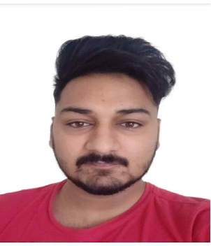

***DR. ARUN KUMAR JINDAL***

**CONTACT**

* **Email**: arunjindal12020@gmail.com
* **Mobile**: 9041014279
* **Address**: Budhlada, District Mansa, Punjab

**CAREER OBJECTIVE**  
To join a reputed healthcare organization as a Psychiatrist, advancing my knowledge and delivering compassionate, evidence-based care to patients.

**EDUCATION**

* **Doctor of Medicine in Psychiatry**  
  *Netaji Subhash Chandra Bose Subharti Medical College,*  
  *Swami Vivekanand Subharti University,* Meerut, Uttar Pradesh  
  **Batch**: 2021–22  
  **Research**: *"Alteration in biological markers in alcohol-dependent male patients during and after detoxification therapy."*

**Poster Presentation**: *A Case of Lithium Toxicity in a Geriatric Patient of Bipolar Mood Disorder,* YPCON-2023, Bhopal, Madhya Pradesh.

* **Bachelor of Medicine, Bachelor of Surgery (MBBS)**  
  *Adesh Institute of Medical Sciences & Research (AIMSR), Adesh University,*  
  Bathinda, Punjab  
  **Batch**: 2012

**CLINICAL EXPERIENCE**  
**Psychiatry Resident**

* Conducted comprehensive patient assessments, including psychiatric evaluations and risk assessments.
* Provided pharmacological and psychotherapeutic interventions for conditions such as anxiety disorders, depression, and schizophrenia.
* Collaborated with multidisciplinary teams to develop individualized treatment plans.
* Actively participated in case discussions and grand rounds.
* Facilitated psychoeducation sessions for patients and families.

**SKILLS**

* Expertise in diagnosing and managing psychiatric disorders.
* Proficient in psychopharmacology and psychotherapy techniques, including Cognitive Behavioral Therapy (CBT) and Dialectical Behavior Therapy (DBT).
* Strong interpersonal and communication skills with patients and multidisciplinary teams.
* Experience in crisis intervention and suicide prevention.

**CERTIFICATIONS AND LICENSES**

* **Medical Council Registration Number**: 54451
* Certified in Advanced Cardiac Life Support (ACLS)
* Certified in Basic Life Support (BLS)

**LANGUAGES**

* Proficient in English, Hindi, and Punjabi.

**REFERENCES**

* Available upon request.