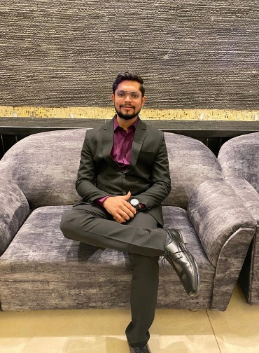 |  |  |  |  | KARAN LALWANI  - GUJARAT | 9106904185 | lkaran544@gmail.com  As an MD Psychiatrist, I apply my expertise in Mental health issues and Addiction psychiatry to diagnose, treat, and prevent Mental health disorders along with substance use disorders. I also have experience dealing with a wide variety of Psycho-sexual disorders. I have completed my Psychiatry residency training at Shri BM Patil Medical College and Hospital, Vijayapura. I hold an MBBS degree from Gujarat Adani Institute of Medical Science, where I graduated in 2019. I have over three years of work experience in the field of psychiatry, working with patients from diverse backgrounds and needs. I have developed skills in clinical assessment, psychotherapy, pharmacotherapy, counseling, and research. I am passionate about improving the quality of life and well-being of people suffering from mental health problems and addiction. I am committed to advancing the knowledge and practice of psychiatry through evidence-based and ethical interventions. I am a team player, a lifelong learner, and a compassionate professional.

Experience
JULY 2020-AUGUST 2023 |  |  |  | SENIOR RESIDENT-DEPARTMENT OF PSYCHIATRY, SHRI BM PATIL MEDICAL COLLEGE HOSPITAL AND RESEARCH CENTRE, VIJAYAPURA  - Interviewed patients concerning physical complaints, discussed symptoms, asked questions, and suggested treatment options.  - Evaluated patient histories, complaints, and current symptoms, and applied scales for screening as well as diagnostic purposes.  - Provided emergent medical care including High-Risk Suicide Management and illnesses along with crisis intervention therapy.  - Performed successfully various therapies such as Cognitive Behavioral therapy, Exposure and Response Prevention therapy, Exposure therapy, Habit Reversal training, Relapse prevention, Motivational Enhancement therapy during my Residency training program.  - Have expertise in performing various Psycho-Sexual therapies such as Genital and Non-Genital Sensate focus.
SEPTEMBER 2013- JANUARY 2019 |  |  |  | MBBS- gujarat adani institute of medical science, BHUJ

Education
AUGUST 2023 |  |  |  | MD PSYCHIATRY-SHRI BM PATIL MEDICAL COLLEGE HOSPITAL AND RESEARCH CENTRE, VIJAYAPURA
January 2019 |  |  |  | BACHELOR OF MEDICINE AND BACHELOR OF SURGERY (MBBS) -GUJARAT ADANI INSTITUTE OF MEDICAL SCIENCES, BHUJ

Skills
- Addiction psychiatry
- Geriatric psychiatry
- Child psychiatry
- Psychotherapies
- Psychopharmacology
- Psycho-sexual disorders

