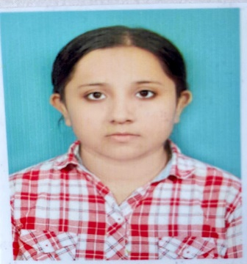RESUME

PRITHA SENGUPTA

**Profile**

An enthusiastic and empathetic aspiring Clinical Psychologist with a strong passion for understanding human behaviour and promoting mental well-being. Committed to fostering a safe, inclusive space for individuals to explore personal challenges. Keenly interested in areas such as Clinical Psychology, Educational Psychology and Mental Health Advocacy. Eager to continue learning and growing in both practical settings as well as academic, to make a meaningful impact in the field of psychology.

**Work experience – Clinical Psychologist**

***Freelancing: Clinical Psychologist***

(Months/Years) of experience: 2 years

Company: Abhasa Rehabilitation and Wellness Centre

***Job Role: Rehabilitation Counsellor***

(Months/Years) of experience: Currently working in the company since, 18th of March 2024

**Other Work Experiences**

***Company: Ways2excel***

Job role: Academic Researcher and Content Developer

(Months/Years) of experience: 5 months

**Education/Academics**

M.Sc in Clinical Psychology: SGT University, Chandu Budhera, Gurugram, Haryana

B.A Psychology (honors): Bethune College, Hedua, Girish Park

ISC: Calcutta Public School, Kalikapur

ICSC: Loreto Convent Entally, Shealdah

**Professional Qualification**

Completed M.sc in clinical psychology

Completed B.A(honors) in psychology

Completed Internship at Antara Psychiatric Centre

Completed Internship at NRS Medical Hospital

Working at Abhasa Rehabilitation Centre, Maharashtra

**Achievement/Awards/Certificates**

Certificate of participation at international conference on projective psychology (2020)

Certificate of merit in subject’s psychology, history, English in ISC examination (Calcutta Public School, 2016)

Certificate of participation at international conference on mental wellness in communities at Kolkata ,2018

Certificate received for an internship at Antara Psychiatric Centre

**Core Competencies**

Good interpersonal skills

Good observer

Good communicating skills

Leadership qualities

Team work skills

**Extra-curricular /Co- Curricular activities**

Participated at international conference on Projective Psychology

Did research in Masters on the title “Effect of loneliness and empathy upon the sharing behavior on Facebook”

**Interest/Hobbies**

Art/ Craft

Reading Books (fiction, non -fiction, motivational)

Listening to music

**Personal Information**

Father’s Name – Mr. Biman Sengupta

Mother’s Name – Mrs. Mitali Sengupta

Date of Birth – 1/1/1998

Religion – Hinduism

Nationality – Indian

Gender: Female

Marital Status – Single

Languages Known – Bengali, English, Hindi

Permanent Address – Sonarpur Milan pally, P. O+P.S – Sonarpur, Kolkata – 700150

**Contact No – 9674718307**

**Email ID – prithusengupta2@gmail.com**