CURRICULUM – VITAE

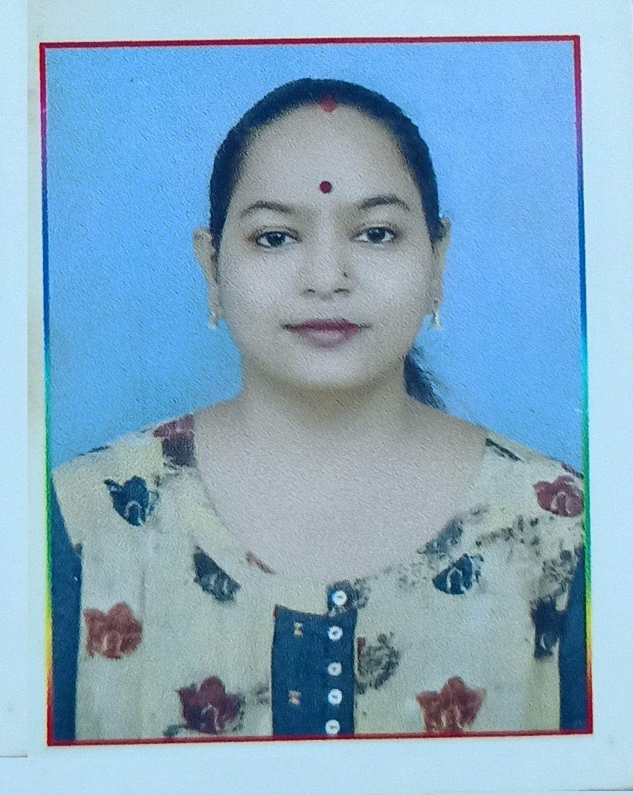 | Permanent Address:  Dr Neha Gupta  w/o Dr Saurabh Lohia  340, Patel Nagar, Konch,  Distt.- Jalaun (U.P.) - 285205  Mob.no.: 7905979859  E-mail: neha.gpt4@gmail.com

_________________________________________________________________________
Career Objective
To work with a prestigious institution with ample opportunities to utilize my abilities and knowledge and be in touch with the latest technologies.
Professional Qualification
- Pursuing CAHC:Certificate (Adolescent Health and Counseling ) from IGNOU.
- PG Diploma in Mental Health (PGDMH) from IGNOU in 2024.
- Postgraduate Diploma in Vocational Guidance and Career Counseling (PGDVGCC) from UPRTOU, Allahabad in Jan to Dec 2020
- Ph.D. in Psychology (Title: Effect of types of marriage (love & arrange), living area (Rural & Urban) on women towards their emotional intelligence marital adjustment and stress) from Ram Manohar Lohiya Avadh University, Faizabad in 2016 (According to UGC-2009)
- Certified Entrepreneurship Development Trainer from NACER Bengaluru.
- Post Graduate Diploma in Computer Application (PGDCA) from YVS college, Gwalior in 2006.
- M.A. (Psychology), Bundelkhand University in 2006.
- M.A. (Sociology), Bundelkhand University in 2008.
- B.Ed. in 2009 from CH. Charan Singh University, Meerut.

Academic Qualification
- B.A. in 2004 from Bundelkhand University, Jhansi, with 63.0% First
- S.S.C. in 2001 from U.P. Board, Allahabad, with 65.00% First
- H.S.C. in 1999 from U.P. Board, Allahabad, with 64.50% First
- CTET 2011 at primary and upper level.
- CTET 2019 at primary and upper levels.
- UPTET 2011 at primary and upper level.
- UPTET 2021 at primary level.

Working Experience
- Worked as Faculty in Allahabad Bank Rural Self Employment Training Institute, Hamirpur, Uttar Pradesh from 15.10.2016 to 16.02.2019.
- Worked as Counsellor psychologist in Jawahar Navodaya Vidyalaya Lalitpur (U.P.) from 10.10.2019 TO 02.06.2022.
- Worked as Counsellor psychologist in Jawahar Navodaya Vidyalaya Jhansi (U.P.) from 08.08.2022 TO 14.10.2024.
- Assistant Professor in Psychology (Guest Lecture) & Freelance Psychologist Consultant Jaipur from 15.10.2024 to till date.
Workshop/Training:
• Online Certificate Course CBT for Depression, Anxiety, Phobias, and Attacks from Udemy
on 31 May 2022
• A Trained Counselor from NLI Udaipur, Attended a one-week training program, designed
under Navodaya Vidyalaya Samiti for counselors from 19.01.2020 to 25.01.2020.

Seminar/Conference:
• A Paper published in International Multilingual Research Journal “Vidyawarta” on “A
comparative study on Love marriage and Arranged marriage working women towards their
Marital adjustment”, Issue-15, Vol-08, July to September 2016.
M AH/MUL/03051/2012, ISSN-23199318
• A Paper published in the International Multidisciplinary Research Journal “Research
Chronicler” on “Effect of stress on working women life”, Vol IV Issue-IV: July 2016.
ISSN- 2347-5021
• A Paper presented on “Psychology and Geeta” under the theme “Indigenous Techniques in
Psychology”, National seminar organized by DSVV Haridwar (March 25-26, 2011)
• A Paper presented on “Solution of Global Warming and Environment Management”
under the theme “ Impact of Environmental aspects on Society”, a National seminar organized
by D.Y.P.G. college, Orai.(March 15-16, 2011)
• A Paper presented on “Terrorism as a Burning Problem and its Basic Reasons” under the
theme “World Wide Assumptions of Terrorism and Its Impact on Indian Economy”, a National
seminar organized by D.Y.P.G. college, Orai. (March 13-14, 2011)
• A Paper presented on “Stress and Coping” under the theme “Stress in Women's life and it’s
Management”, National seminar organized by D.Y.P.G. college, Orai (December, 17-18, 2005)

Achievements:
- Wrote an article on “ Stress and Coping” for a college magazine and achieve lots of applauds (2005)
- Secured Ist position in “Debate” competition in college fest (2004)
- Actively participated in quizzes, debates, and cultural competitions during school days.
Interests & Hobbies:
- Writing articles, stories, And poetry
- Reading literature, Novels, and Articles
- Listening /Singing Music, news
- Cooking and Handcrafting
Strengths:
- Strong working stamina with good emotional intelligence
- Good communication skills with strong Convincing Power
- Proficiency in oral and writing skills
- Confident & Flexible Nature
- In-Depth knowledge of Psychology, Entrepreneurship Development.

Personal Profile:
Father’s Name : Sh. R.S. Gupta
Mother’s Name : Smt. Aruna Gupta
Date of Birth : May 23, 1984
Marital status : Married
Nationality : Indian
Language Known : English & Hindi
Permanent Address : 340, Patel Nagar, Konch
Jalaun (U.P.) 205205 _____________________________________________________________________________
I hereby declare that all details furnished above are true to the best of my knowledge & belief.
Date: ___________ ____________
Place: Jaipur (Dr Neha Gupta)

