**SWATI MALHOTRA**

*STUDENT*

[Swati.malhotra@science.christuniversity.in](mailto:Swati.malhotra@science.christuniversity.in) | [Swatimalhotra503@gmail.com](mailto:Swatimalhotra503@gmail.com) | +91 8595591643

Permanent Address: K3/80, Ground Floor, DLF Phase 2, Gurugram, Haryana

 May 3rd 2002

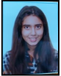

**OVERVIEW**

I am a self-driven and enthusiastic psychology major’s student, currently pursuing BSc psychology Honours from Christ (Deemed to be) University, Bangalore- Kengeri Campus, and am currently in my 2nd year (4th semester) of my 3-year graduation program. I am interested in the fields of clinical psychology and neuropsychology and would like to apply for master in the above-mentioned courses. I am a hard working and dedicated individual who is open to new experiences and challenges.

**EDUCATION**

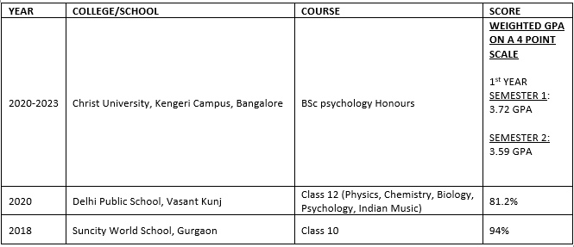

**AWARDS AND ACHIEVEMENTS**

* Distinction in piano and keyboard-grade 3 from Trinity College London (2012-2017)
* Competitive Inter School Chess Competitions (2014-2018)
* Bronze level in District Level Skating (2014)
* Certificate of Appreciation from Zee News Channel for debating and Oration (2015)
* Winners of inter school Street Play Competition and Certificate of Participation from Fortis Gurugram and Medanta Medicity, Gurugram for Street Play on Environmental awareness (2016)
* 1 Silver medal and 1 bronze medal in debating, literature and science in World’s Scholars Cup- Nationals. Got Selected for the International Round that took place in Hanoi (2018)
* Junior Diploma in Indian Classical Vocal Singing from Prayag Sangeet Samithi (2019)
* Senior Diploma from Satya Sai Seva Organization (2008-2019)
* Gold Medal in inter school Classical Singing Competition- Group category (2019)
* Certificate of Appreciation for several inter school psychology debate competitions (2018-2020)
* Qualified NEET 2020
* Organizing and Heading events at College Deanery Level- Certificate of Appreciation and participation (2021)
* Certificate of appreciation for organizing the menstrual health awareness program and heading the social media team for the same (2021)
* Certificate of Appreciation for heading Kaleido’21
* Certificate of Appreciation for participating in COVID’19 Vaccination Drive- IM Gurugram (2021)

**EXTRA CURRICULAR ACTIVITIES/ OTHER EXPERIENCES**

* Discipline Head- Suncity World School, Gurugram (2017-2018)
* Vice House Captain- Delhi Public School, Vasant Kunj (2018-2019)
* Management and Sponsor Team, Arthashastra- Delhi Public School, Vasant Kunj (2018-2020)
* Vice President, Drama and Debate Society- Delhi Public School, Vasant Kunj (2019-2020)
* Class Representative, Year 1 - Christ University Bangalore (2021)
* Honorary Member of Centre of Social Action- Christ University Bangalore (2021)
* Student Welfare Office, Volunteering Body- Christ University Bangalore (2021)
* Psychology Association, Student Coordinator- Christ University Bangalore (2021-2022)
* Kaleido’21, Event head and Core Committee member- Christ University Bangalore (2021)
* Natyaarpana dance society- Christ university Bangalore (2021-2023)
* Psychnautz, Psychology Department social media page, editing team- Christ university Bangalore (2021)
* Student Welfare Office- Emceeing Body (2021-2023)
* Emceeing the college level Open Mic event- 2021 and College Annual Day (Darpan’21)

**PROFESSIONAL EXPERIENCE (INTERNSHIPS)**

* Lal Nursing Home (May-June 2018)
* AIIMS Delhi (April 2019)
* Earths Saviour Foundation- Voluntary service (2017-2020)
* Young Psychologist Program- 1 Month Internship (2020-2021)
* Udayan Care- 1 month Internship (April- May 2021)
* Indian Mental Health and Research Centre- 1 Month Internship (May- June 2021)

**CERTIFICATE COURSES**

* Science of Happiness- University of Berkeley (May 2018- December 2019)
* Insights to Neuroscience, Harvard University(May 2019-December 2020)
* Principles of Human Resource Management, IIT Kharagpur (2020-2021)
* Science of Wellbeing- Christ university Bangalore (2020)
* Designing Policies for Sustainable Development- Christ University Bangalore (2021)
* Numerology Practitioner Course (2021)
* Introduction to Neuroeconomics, How the Brain Makes Decisions- HSE University (2022)
* Health Behaviour Change: From evidence to action- Yale University (2022)
* Medical Neuroscience- Duke University (2022)
* Managing emotions in the times of Uncertainty and Stress- Yale University (2022)

**SOFT SKILLS**

Communication, Leadership, Collaboration, organizing, problem solving, interpersonal, Team Building

**LANGUAGES**

English, Hindi

**INTERESTS**

Mining Music. Singing, Classical and Freestyle dancing, Reading Philosophical and realistic fiction, engaging in sports like swimming, chess and Table tennis, writing poems, Zodiacs and astrology, teaching, emceeing and volunteering