SUCHITAA  Ats Advantage, Indrapuram, Ghaziabad.UP.  E-mail: suchitathakkar.59@gmail.com  Mobile No : 9810981199 | 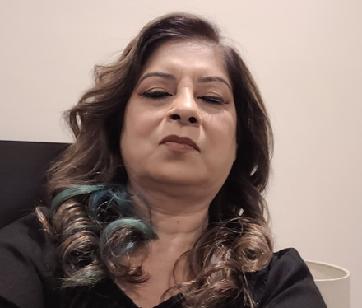

“Experience Prowess, Knowledge, Maturity are not bound by age – it is the learning tendency, caliber, endeavor, zeal, optimism and willingness which lands a person at pinnacle at any age.”
Work Experience:
1) Name of Organisation: 1. RYAN INTERNATIONAL SCHOOL, DELHI
Designation: PRT. Science.
Duration: October- 1996 to May 2008.
2) Name of Organisation: KOTHARI INTERNATIONAL SCHOOL,NOIDA
Designation: PRT- Science. Activity Coordinator.
Duration: June 2008 to 2018
3).Name of hospital: SHANTI MUKUND HOSPITAL, EAST DELHI
Worked under Dr. Manish Kansal. As a psychologist.
3).Name of the institute: THE COUNSELLING INSTITUTE DELHI
. Worked as a counselor under Dr. Kamal Khurana
4.) Counselor and Hypnotherapist: Working from home as a psychological counselor and hypnotherapist under the name: Understanding Minds.
5) Name of the company: COUNSEL INDIA DELHI.
Worked as a Counselor for 1 year.
6) Name of the institute: TALK TO ANGEL:
Joined them as counselling psychologist.
Doing online counselling.
7). Name of the company: EMO MATRIX, NOIDA
Worked as a mental health counselor.
8). ROYAL PSYCHOLOGIST COMMUNITY
( PAKISTAN) Working as a Psychologist, Conducting
Webinars and workshops.
9). CARE FOUNDATION
REHABILITATION CENTRE
(NOIDA) Working as a clinical Psychologist.
10) Working as a therapist with. Live, Love, Laugh foundation. ( Founder Ms. Deepika Padukone)
11). Pursuing PHD In Psychology.
Glocal University Saharanpur(UP)
12. Manastha Wellbeing: Working as a consultant psychologist.
Remote and Hybrid role.
Strengths:-
Positive attitude to make a bright future.
Cooperative nature and efficient team member.
Assertive planning, management and implementation to prove myself.
Smart working is decided, determined and self motivated to make a job satisfaction.
Qualification:-

Course | Institute
M.A. Psychology. | Global Institute of Nagaland.
M.S. Psychotherapy and Counselling./  Rehabilitation Psychology | IPMS Mumbai.  Shanghai University of Manipur
Hypnotherapy | EKKA
Child Psychology Royale Institution
Tarot Card Reading
MA in Clinical Psychology IGNOU.
Certificate in child guidance: IGNOU.
RCI Registration Number: Course done from Vision Institute
Name of the course: DVR ID rci registration number
rci-2024-250586-Y-2024-10-114
SKILLS: Can do CBT, Deal with clients having Anxiety, Depression, Phobia, Stress, Relationship Issues, OCD, Couple
Counselling, Marriage Counselling.Schizophrenia,Psychotic disorders, Over thinking
\’Personal Details:-
Date of birth :- 5th March
Birth place :- Nagpur.
Marital Status :- Married
Husband :- Lt. Mr. Bharat Thakkar
Language Known :- English, Hindi , Gujarati, Marathi.
DATE: 24.10.2024
PLACE: INDRAPURAM Suchitaa.
COVERING LETTER
I am a clinical and counselling psychologist, with 9 years of experience in counselling. I have a pleasing personality, confident, can speak Hindi and English. Currently working from my own clinic Understanding Minds. I do online & offline counselling. I deal with clients having issues like, Anxiety, Depression, Phobia, Schizophrenia, relationship issues, couple counselling and many more. I am hard working, accepting all kinds of challenges given to me.
I have 9 years of experience as a counselling and clinical psychologist. I have clients having mental health issues like, Anxiety, Depression, Phobia, Relationship problems also. I am looking forward to work with you, it would be a great honor for me.
Waiting for a positive response from you.

